LABORATORIO ARTIGIANO RETI
di ARCHETTI CARLO
Reti da Pesca – Sport – Caccia
Recinzione Impianti Sportivi
Antinfortunistica – Acquacoltura
25058 SULZANO (BS) – Via Tassano, n. 8
Tel. e Fax 030/985290 – Tel. Ab. 030/985191
Cell. 328 0562071 c.f. RCHCRL64C01F532U – P.I. 03216410179
www.retiarchetti.it – info@retiarchetti.it
www.retiarchetti.com – info@retiarchetti.com
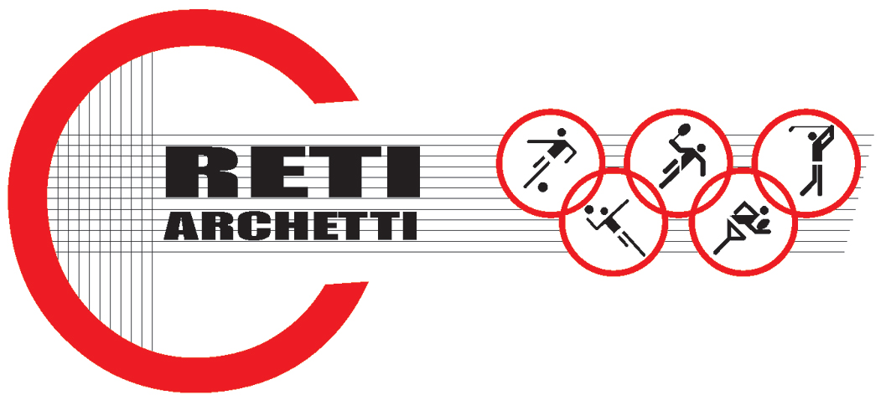

TECHNICAL DATA SHEET ART.CODE: A P/N

NET MADE OF MIX POLYETHYLENE AND HIGH RESISTANT NYLON, MESH mm 42 x 42 AND THICKNESS mm 4

SQUARED MESH NET

YARN THICKNESS 210/96 - Ø 4 mm

MESH mm 42 x 42

UNMOVABLE STRANDED KNOT

MATERIAL: MIX POLYETHYLENE AND NYLON

COLOR: WHITE

HUMIDITY ABSORPTION 10%

MATERIAL CAN BE EXPOSED TO THE FOLLOWING TEMPERATURE – 10 + 20. GUARANTEE: 4YEARS

SLOW COMBUSTION

STABLE PRODUCT

MANUFACTURED AT CONTINUOUS EXTRUSION

ULTIMATE STRENGTH (TO PULL A MESH FROM ONE END TO THE OTHER): KG. 102

